**Access Control Lists**

 the standard **ugo/rwx** set does not allow to configure different permissions for different users, **ACLs** were introduced in order to define more detailed access rights for files and directories than those specified by regular permissions.

Access Control Lists (ACLs) in Linux are used to provide more fine-grained control over file and directory permissions. While the traditional Unix file permissions (read, write, execute) are limited to owner, group, and others, ACLs allow you to specify permissions for specific users and groups, enabling a more flexible and detailed level of access control. ACLs are particularly useful in situations where you need to grant or restrict access to files and directories for specific users or groups without changing the existing ownership or group settings.

**USAGE: Type getfacl (file or directory name) to get the info about the permissions on the file or directory.**

**# getfacl harry.txt**

**(NOTE= -m is for modification, -x is for remove permission, -b is to remove all acl entries or modification, -Rm can be used to give permission to a user for all files in a specific folder by specifying folder name.)**

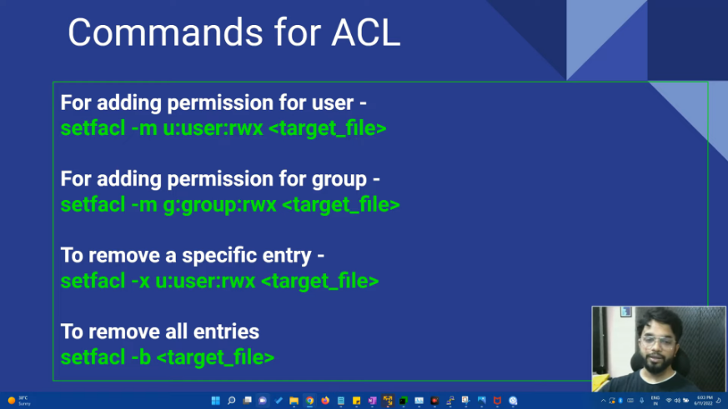

**NFS**

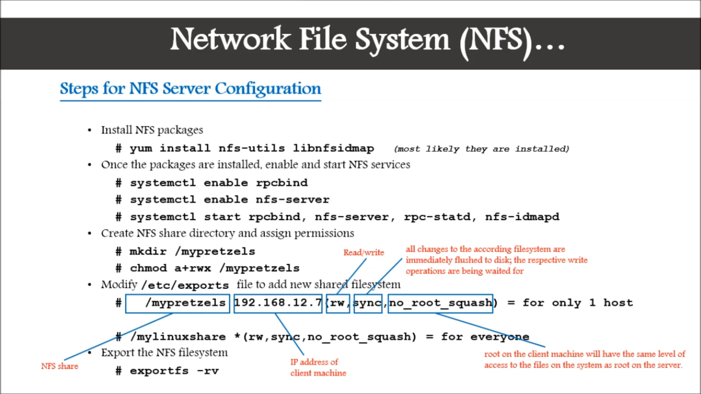

**(## NOTE 1: Disable firewalld on both server and client by typing systemctl disable firewalld1**

**## NOTE 2: You have to be on the same network or you can use LAN to connect but disable wifi if You connect via LAN**

**##NOTE 3: You have to set Briged network connection on both VMs server and client. Go to VM settings choose network tab change Network Connection from NAT to Briged, Click OK.)**

**SAMBA SERVER**

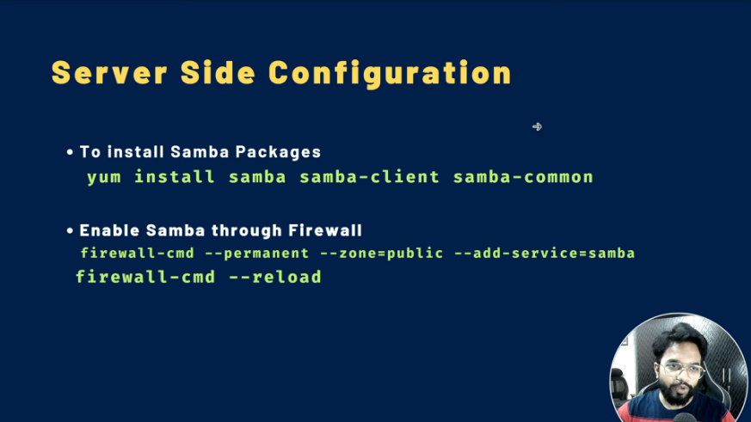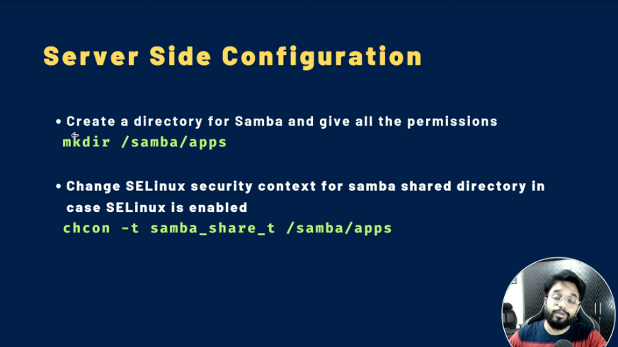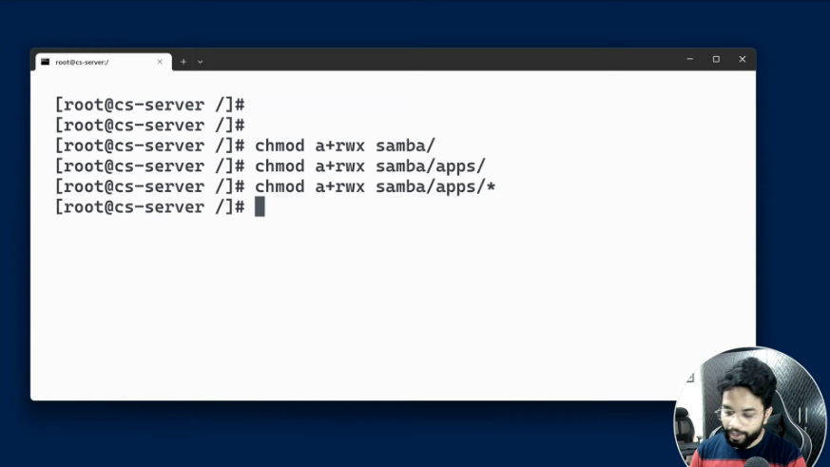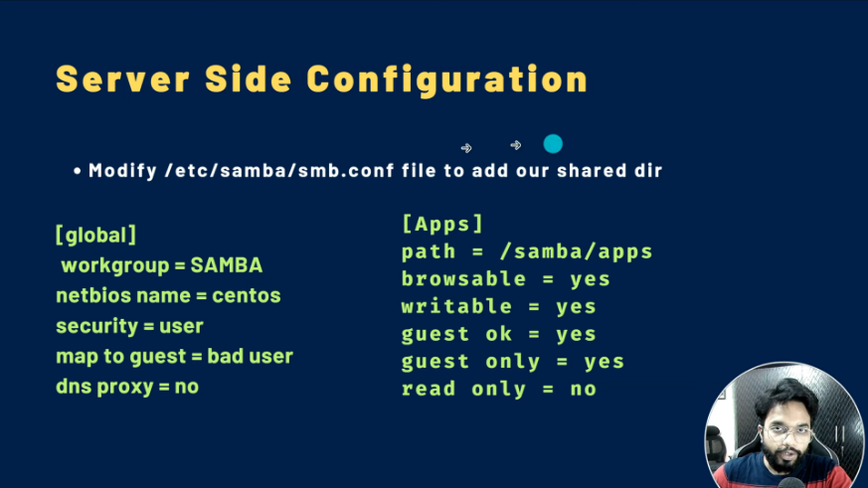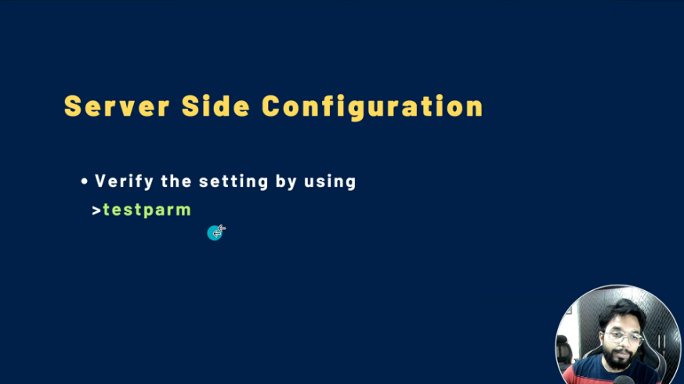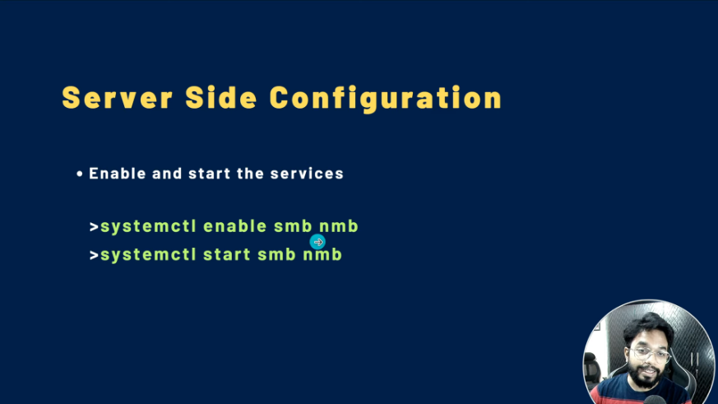

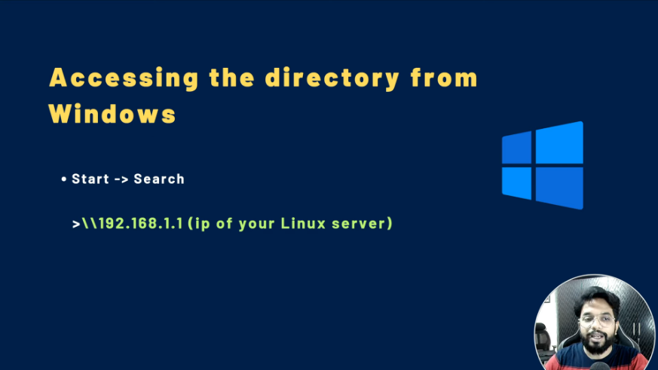

**(NOTE: Change the owner of the folders and file by typing =># chown nobody:nobody /samba**

**=># chown nobody:nobody /samba/apps**

**=># chown nobody:nobody /samba/apps/\***

**Disable firewall by typing systemctl disable firewalld).**

**(NOTE: #When trying to log into server via Windows if it asks for user name and password – type user name as = root and leave the password as blank or type your original password).**